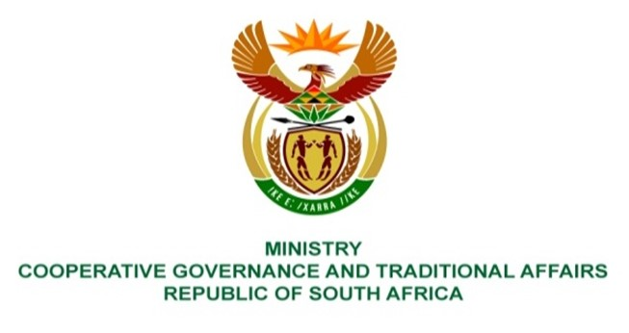

NATIONAL ASSEMBLY
QUESTIONS FOR WRITTEN REPLY

QUESTION NUMBER 1267
DATE OF PUBLICATION: 14 MAY 2021

QUESTION:

1267. Mr H S Gumbi (DA) to ask the Minister of Cooperative Governance and Traditional Affairs:

What is the total (a) number of water tankers that operated in the Inanda area since 2010 and (b) amount spent on (i) water tankers and (ii) bulk infrastructure in the specified area in each specified year?

1267
Financial year | Description | Project No. | YTD Actuals (at 30 April 2021) | Total per FY in Rm
2020-21 | INANDA NEWTOWN C SEWER RETICUL | Y8136D | 0.818
 | INANDA B-SINAMUVA DRIVE SEWER | Y8783D | 0.228
 |  |  | 1.046 | 1.046
2019-20 | Umbhayi Housing Development | X8224 | 0.152
 | INANDA NEWTON C SEWER RETICULATION | Y8136B | 5.630
 | INANDA NEWTOWN C SEWER RETICUL | Y8136C | -
 | INANDA NEWTOWN C SEWER RETICUL | Y8136C | -
 |  |  | 5.782 | 5.782
2018-19 | INANDA NEWTON C SEWER RETICULATION | Y8136B | 0.186
 | Inanda B Sinamuva drive sewer | Y8783 | 0.268
 |  |  | 0.454 | 0.454
2017-18 | Inanda Newtown 'C' Sewer Reticulation | Y8136B | 0.138
 |  |  | 0.138 | 0.138
2016-17 |  |  | -
 |  |  |  | 0
2015-16 |  |  | 0
 |  |  |  | 0
2014-15 |  |  | 0
 |  |  |  | 0
2013-14 | Inanda Glebe Sewer Reticulation | Y6459 | 0.079
 |  |  | 0.079 | 0.079
2012-13 | Etafuleni phrase1 and 2 collector | Y6523 | 2.871
 |  |  | 2.871 | 2.871
Grand total |  |  |  | 10.3698

BACKGROUND INFORMATION:

It is to be noted that parliamentary question require information since 2010, however information submitted by the Ethekwini Metro is for period since 2012/13 financial year. According to the Metro, information before 2012/13 is not readily available and therefore will require more time to be extracted and submitted.

