National Assembly

Question No 1260

Mr K P Sithole (IFP) to ask the Minister of Transport:
What number of claims against the Road Accident Fund (a) have been recorded from 1 January 2015 to date, (b) have been paid in the specified period in each province and (c) are still outstanding? NW1516E

REPLY

The number of claims (personal claims and supplier claims combined) against the Road Accident Fund (RAF) (a) registered from 1 January 2015 to 31 March 2022 is 1,571,647, (b) in the specified period a total of 1,034,930 (66%) claims have been paid (capital); payment has been requested but has not yet been paid (RNYP) in respect of 10,184 (0.6%) claims; 197,180 (12.5%) claims were repudiated; 48,429 (3.1%) claims were flagged as duplicate claims and, or, objected to; 3,418 (0.2%) claims were finalised without a capital payment; and 1,840 (0.1%) claims were finalised with undertaking certificates but with no capital paid to date; which claim statistics is broken down per RAF regional office as follows:

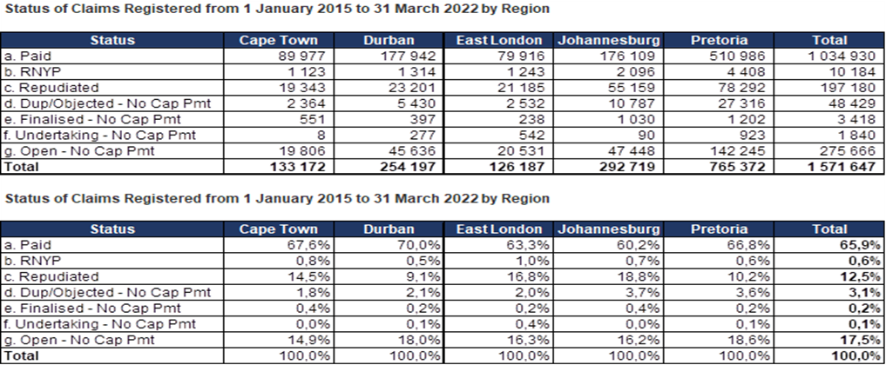

(c) and 275,666 (17.5%) claims remain on an open claims status with no capital paid or requested to date.

