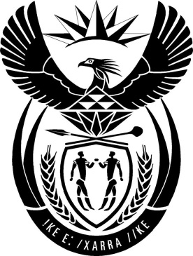

MINISTRY: PUBLIC SERVICE AND ADMINISTRATION

REPUBLIC OF SOUTH AFRICA

NATIONAL ASSEMBLY

QUESTION FOR WRITTEN REPLY

QUESTION NO.: 126.

Dr L A Schreiber (DA) to ask the Minister of Public Service and Administration:
(1) What number of public service employees have been found to have conducted business with the State in contravention of section 8 of the Public Administration Management Act, Act 11 of 2014, since its inception;
(2) whether any of the specified public service employees were successfully prosecuted and subjected to a fine or imprisonment for contravening section 8 of the specified Act; if not, why not; if so, what are the relevant details in each case;
(3) whether any of the public service employees have had their employment terminated for contravening section 8 of the Act; if not, why not; if so, what are the relevant details? NW1087E

REPLY
- The DPSA identified twenty public service employees who may have conducted business with the State and therefore, may be in contravention of section 8 of the Public Administration Management Act, 2014.
- No public service employees were prosecuted or fined for contravening section 8 of the specified Act. However, on 24 June 2019, the DPSA submitted a list of twenty employees referred to in paragraph 1, to both the National Commissioner of the South African Police Service and the National Director for Public Prosecutions, with a request to conduct the necessary investigations and possible prosecutions.
- No public service employee has had their employment terminated for contravening section 8 of the Act; as the identified cases still need to be investigated.

END

