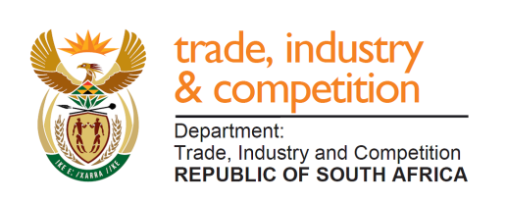

THE NATIONAL ASSEMBLY

QUESTION FOR WRITTEN REPLY

PARLIAMENTARY QUESTION 1259

Mr T W Mhlongo (DA) to ask the Minister of Trade and Industry:

(1) What (a) is the current total cost of renovating the Credo Mutwa museum and library in Kuruman, Northern Cape and (b) amount was (i) allocated for the specific library, house and museum project by (aa) the Northern Cape government and (bb) his department and (ii) donated by the National Lotteries commission towards the construction of the Credo Mutwa museum;
(2) (a) on what date was the museum and library renovation project supposed to be completed and (b) by what date will the project be completed;
(3) whether any investigation was conducted regarding mismanagement and/or maladministration of the project; if not, why not; if so, (a) what is the status of the investigation, (b) will he furnish Mr T W Mhlongo with a progress report and (c) what is the case number allocated to the investigation? NW2471E

REPLY:

I have been advised by the department as follows:

“(1) (a) Only NLC funded the project.
(b) (i) (aa) no funding from the Northern Cape Government (bb) no funding from the department and (ii) the NLC approved R19 Million for the following key items: construction of a new Library and Museum, operational cost (including free Wi-Fi to the public), appointment of the Librarian and a Curator. The project relating to the renovation of Mr Mutwa’s home was sanctioned by the Northern Cape Department of Sports, Arts and Culture and NLC did not play a role.

- (a) The construction of the Library and Museum commenced in December 2017
and was completed in September 2018. The project was launched/handed
over to the community on the 15th April 2019.
(b) The project is fully completed in line with the budget allocated by the NLC, the
project was handed over and since then it has been fully utilized by the community.

- No (a) Not applicable (b) Not applicable (c) None “

-END-

