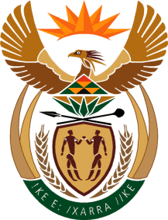

MINISTRY OF TOURISM
REPUBLIC OF SOUTH AFRICA

Private Bag X424, Pretoria, 0001, South Africa. Tel. (+27 12) 444 6780, Fax (+27 12) 444 7027
Private Bag X9154, Cape Town, 8000, South Africa. Tel. (+27 21) 469 5800, Fax: (+27 21) 465 3216

NATIONAL ASSEMBLY:

QUESTION FOR WRITTEN REPLY:
Question Number: 1258
Date of Publication: 14 May 2021
NA IQP Number: 13
Date of reply: 20 May 2021

Mr M S F de Freitas (DA) to ask the Minister of Tourism:

(a) What measures have been taken to maximise the communication and relationships with the Department of International Relations and Cooperation in order to grow tourism, (b) how is the communication and relationships with the specified department (i) monitored and/or (ii) measured and (c) what have been the (i) successes and/or (ii) failures (aa) in the past three financial years and (bb) since 1 April 2021? NW1449E

REPLY:

- Measures to maximize communication with DIRCO
Communication between the Department of Tourism and the Department of International Relations and Cooperation (DIRCO) is institutionalised and effective. The department works with DIRCO on matters pertaining to the implementation of tourism Bilateral and Multilateral Relations and Cooperation. The department working with South Africa Tourism and DIRCO provides support to South Africa’s missions to support tourism growth in pursuit of economic diplomacy.

- (i) and (ii) How is communication monitored and measured?
Through management reporting.

- (i) an ( ii) Success and failures of the (aa) past three financial years and (bb) since 1 April 2021
(aa) Since the establishment of the standalone Department of Tourism the two departments work well together resulting in, amongst others, the identification of Tourism as a pillar of Economic Diplomacy.

(bb) Since the onset of COVID-19 both departments adjusted well to working remotely and have kept constant virtual contact.

