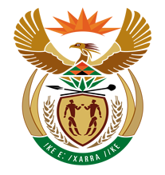

NATIONAL ASSEMBLY

QUESTION FOR WRITTEN REPLY

QUESTION NUMBER: 1256 [NW1397E]

DATE OF PUBLICATION: 19 MAY 2017

1256. Adv A de W Alberts (FF Plus) to ask the Minister of Finance:
(1) With reference to the collection of tax and income tax by the SA Revenue Service (SARS), (a) what number of (i) natural persons and (ii) juristic persons have been registered for income tax for the (aa) five most recent tax years and (bb) current tax year, and (b)(i) to what number of the specified number of persons were income tax refunds owed by SARS in each of the specified tax years and (ii) what was the percentage of persons in relation to the total number of registered income tax payers to whom income tax refunds were owed in each of the specified tax years;
(2) what was the total (a) amount and (b) percentage in relation to the paid income tax amount and percentage that had to be refunded for each of the specified tax years? NW1397E
REPLY:

The OTO announced earlier this year that they will be launching an investigation with regards to the refund processes administered by SARS to better understand the challenges, risks and complexity associated with the process. The investigation is currently underway and SARS is committed to working with the OTO to give them the required insight into the process so that they will be able to satisfactorily give feedback to the public on their findings.

SARS would want the current investigation underway to first be concluded before additional responses to the topic at hand is made as this stage.

