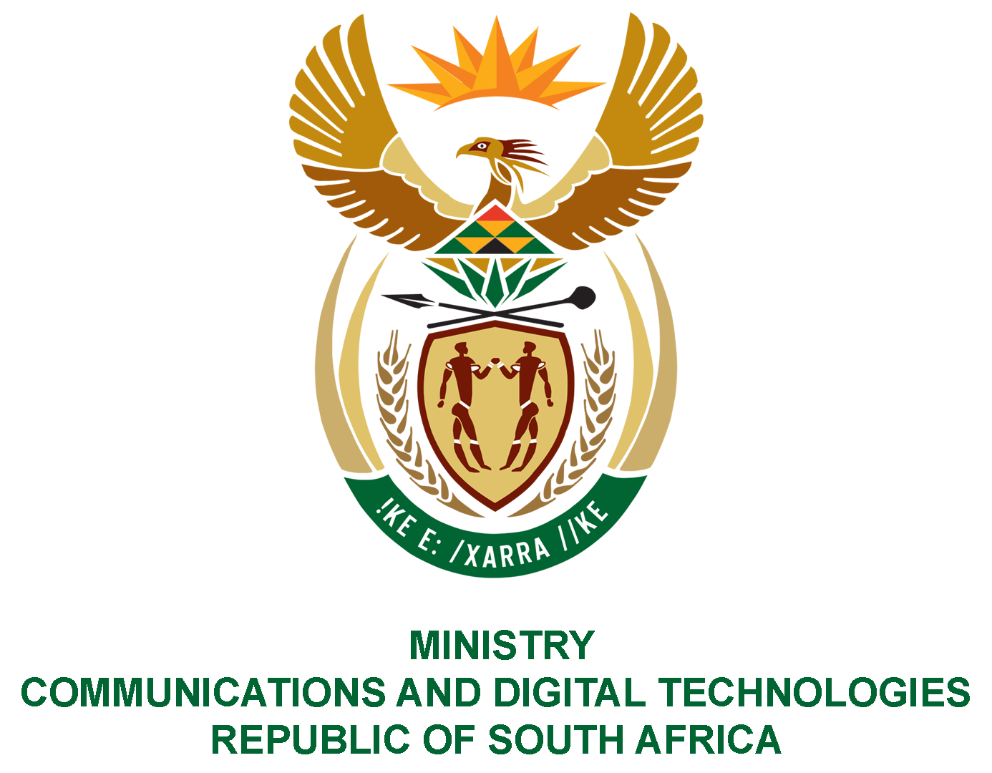

PARLIAMENT OF THE REPUBLIC OF SOUTH AFRICA

NATIONAL ASSEMBLY

WRITTEN REPLY

QUESTION: 1255

DATE OF PUBLICATION: 1 APRIL 2022
QUESTION PAPER NO: 13
Ms Z Majozi (IFP) to ask the Minister of Communications and Digital Technologies:
In light of the fanfare that has been made by her department about the long-awaited and delayed migration from analogue to digital and the concerning flurry of media reports over the past week in the run-up to the 31 March 2022 cut-off date, with broadcasters claiming that they are not ready and are asking for an extension (details furnished), (a) what number of (i) set-top boxes still need to be installed and (ii) South Africans will be left without television come 31 March 2022 and (b) will she furnish Ms Z Majozi with the complete figures?
NW1511E
REPLY:
I have been advised by the Department as follows:
(a) (i) At the time of publication of the question, the Gauteng High Court had extended the date for analogue switch off to 30 June 2022. The numbers that were due for installations by 30 June 2022 as per Gauteng High Court judgement were completed by the set date except for 106, 571 in KZN and Eastern Cape due to the impact of the floods.
(ii) There is no way of knowing the number of households watching TV through analogue TV sets and it is for that reason that government called for those watching TV through analogue and qualifying for government assistance to apply for assistance. In addition, Digital television cannot only be watched through STBs but digital television sets which were already sold in South Africa since 2012. Between 2016 to date, more than 2.6 million Digital TV sets have been sold in South Africa and can be deemed majority TV sets in households. Furthermore, government has taken measures to ensure South Africans do not unknowingly buy Analogue TV sets in the market.

(b) Refer to (a) above

