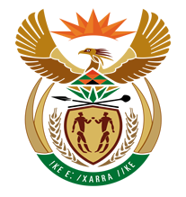
NATIONAL ASSEMBLY

QUESTION FOR WRITTEN REPLY

QUESTION NUMBER: 1255 [NW1396E]

DATE OF PUBLICATION: 19 MAY 2017

1255. Adv A de W Alberts (FF Plus) to ask the Minister of Finance:
(1) With reference to the collection of tax and value-added tax (VAT) by the SA Revenue Service (SARS), (a) how many (i) natural persons and (ii) juristic persons have to date been registered for VAT tax for the (aa) five most recent tax years and (bb) current tax year, and (b)(i) to what number of the specified number of persons were VAT refunds owed by SARS in each of those years and (ii) what is the percentage of persons in relation to the total number of registered VAT payers to whom VAT refunds were owed in each of the specified years;
(2) what is the total (a) amount and (b) percentage in relation to the paid VAT amount and percentage that had to be refunded for each of those years? NW1396E
REPLY:

The OTO announced earlier this year that they will be launching an investigation with regards to the refund processes administered by SARS to better understand the challenges, risks and complexity associated with the process. The investigation is currently underway and SARS is committed to working with the OTO to give them the required insight into the process so that they will be able to satisfactorily give feedback to the public on their findings.

SARS would want the current investigation underway to first be concluded before additional responses to the topic at hand is made as this stage.

