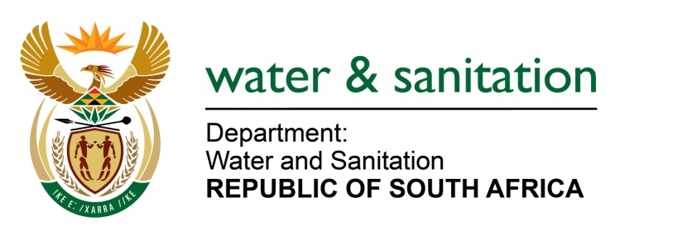

NATIONAL ASSEMBLY

FOR WRITTEN REPLY

QUESTION NO 1251

DATE OF PUBLICATION IN INTERNAL QUESTION PAPER: 1 APRIL 2022
(INTERNAL QUESTION PAPER NO. 13)

1251. Ms S A Buthelezi (IFP) to ask the Minister of Water and Sanitation:
What action has his department taken to ensure the development and innovation of water infrastructure for catchments?
NW1507E

---00O00---
MINISTER OF WATER AND SANITATION

In South Africa many catchments are water stressed and this necessitates implementation of various measures to secure water resources in all the catchments in the country. The Department of Water and Sanitation (DWS) gives effect to the development and innovation of water infrastructure through the National Water Resource Strategy.

The DWS undertakes continuous scenario planning to ensure water security for the country. The key outputs of the scenario planning are strategies and projects to reconcile water requirements and availability for all large integrated systems in the country and localised water resource systems that secure water for small towns, villages or clusters of settlements.

Broadening of South Africa’s water resource mix is critical for water security as there are now limited opportunities for further surface water developments. To address this, the DWS:
- Is developing guidelines and a national strategy for supplementing surface water resources with groundwater resources in a sustainable fashion.
- Is importing surface water from neighbouring countries;
- Will increasingly be supporting municipalities to develop alternative sources of water, including through desalination and water re-use;
- Is encouraging and supporting municipalities to implement water conservation and demand management strategies, including reducing water losses; and
- Will increasingly be working with industries to increase water-use efficiency.

The Department of Water and Sanitation is currently in the process of establishing the National Water Resource Infrastructure Agency (NWRIA). Once established, the NWRIA will be able to finance and implement large-scale investments in national water resource infrastructure that are required to ensure that South Africa has sufficient bulk water supply.

---00O00---

