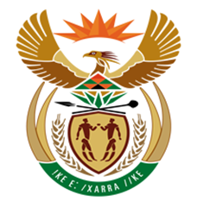

NATIONAL ASSEMBLY

QUESTION FOR WRITTEN REPLY
QUESTION NUMBER: 1250 [NW1391E]
DATE OF PUBLICATION: 19 MAY 2017

1250. Mr B R Topham (DA) to ask the Minister of Finance:
(1) Why were members of the Standing Committee on Finance not invited by the National Treasury to attend the 2017 World Economic Forum on Africa held in Durban between 3 and 5 May 2017;
(2) whether he will make a statement on the matter? NW1391E

REPLY:
The Presidency is responsible for invitations to the World Economic Forum on Africa meetings and not the National Treasury. Only the Presidency has the prerogative to extend invitations. The National Treasury is delegated by the Presidency to organise logistics for the convening of the conference, however invitations do not form part of the delegated mandate.

