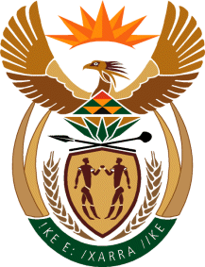

DEPUTY PRESIDENT: REPUBLIC OF SOUTH AFRICA

Private Bag X 1000, Pretoria, 0001

NATIONAL ASSEMBLY
QUESTIONS FOR WRITTEN REPLY
FRIDAY, 01 APRIL 2022

1249. Inkosi B N Luthuli (IFP) to ask the Deputy President:

Whether the Human Resources Development Council has any strategies that are aimed at improving the scarcity of technical and/or other skills in order to promote the relevance of the South African education system in line with the international standards as well as the sustainability of our economy; if not, why not; if so, what are the relevant details? NW1505E

REPLY:

The Human Resource Development Council has developed a Human Resource Development Strategy which is in line with the National Development Plan. The Human Resource Development strategy outlines the vision for the development of human resources in South Africa, and the role that it will play in meeting the country’s economic, development and social needs.

Among others, the Human Resource Development strategy outlines the South African Human Resource Development commitments on the need to: increase the supply of priority skills to achieve accelerated economic growth, and to increase the number of appropriately skilled people to meet the country’s economic and social development priorities.

The Human Resource Development Strategy towards 2030 has five programme priorities to address key technical skills to promote the relevance of the South African education system. The programmes are as follows:
- Programme 1: Strengthening basic education and foundation programmes in Science, Technology, Engineering, Maths, languages, and Life Orientation/skills.
- Programme 2: Expanding access to quality post-schooling education and training.
- Programme 3: Improving research and technological innovation outcomes.
- Programme 4: Production of appropriately skilled people for the economy.
- Programme 5: A developmental/capable State.

The Council is currently reviewing the Human Resource Development Strategy to incorporate the recommendations of a ten-year review work of the Human Resource Development Council, and the outcomes of the HRDC 2021-2024 strategic planning. Furthermore, in order to sustain the economy of the country which has been affected by the COVID-19 pandemic, the Department of Higher Education and Training has developed a Skills Strategy to respond to the Economic Recovery and Reconstruction Plan.

-END-

