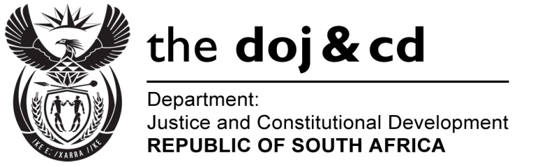

**NATIONAL ASSEMBLY**

**QUESTION FOR WRITTEN REPLY**

**PARLIAMENTARY QUESTION NO: 1248**

**DATE QUESTION PAPER: 06 May 2016**

**DATE OF SUBMISSION: 20 MAY 2016**

**Mr D J Maynier (DA) to ask the Minister of Justice and Correctional Services:**

1. With reference to the Commission of Inquiry into Allegations of Fraud, Corruption, Impropriety or Irregularity in the Strategic Defence Procurement Packages, what is the (a) total amount spent and (b) breakdown of such expenditure on the specified commission since its establishment in 2011 to date;
2. What is the (a) total amount spent and (b) breakdown of such expenditure on the compensation of each (i) evidence leader, (ii) forensic auditor and (iii) research consultant working for the specified commission since its establishment in 2011 to date?

**NW1396E**

**REPLY:**

1. (a) The total amount spent on the Commission of Inquiry into Allegations of Fraud,

Corruption, Impropriety or Irregularity in the Strategic Defence Procurement Packages

as at 31 March 2016 is R137, 264, 521.

(b) The table below provides the breakdown of the expenditure since its establishment in

2011 to date:



1. (a) Total amount spent on evidence leaders, forensic auditor and research consultant is

R93, 148, 779.

1. The tables below provide the breakdown of expenditure as follows:
2. Evidence leaders:



1. Forensic Auditor:



(iii) Research Consultant:

