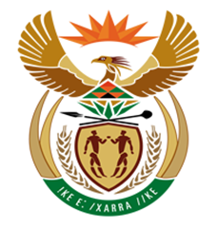

NATIONAL ASSEMBLY

QUESTION FOR WRITTEN REPLY
QUESTION NUMBER: 1247 [NW1388E]
DATE OF PUBLICATION:

1247. Mr D J Maynier (DA) to ask the Minister of Finance:
(1) Whether he has ever travelled on a private aircraft between Johannesburg and Durban in fulfilment of his official Cabinet responsibilities since 26 May 2014; if not, what is the position in this regard; if so, (i) when did each such trip take place, (ii) what was the purpose of each trip, (iii) who was the owner of each aircraft, (iv) what was the tail number of each aircraft and (v) who accompanied him on each trip;
(2) Whether he will make a statement on the matter?
NW1388E
REPLY:

(1-2) No.

