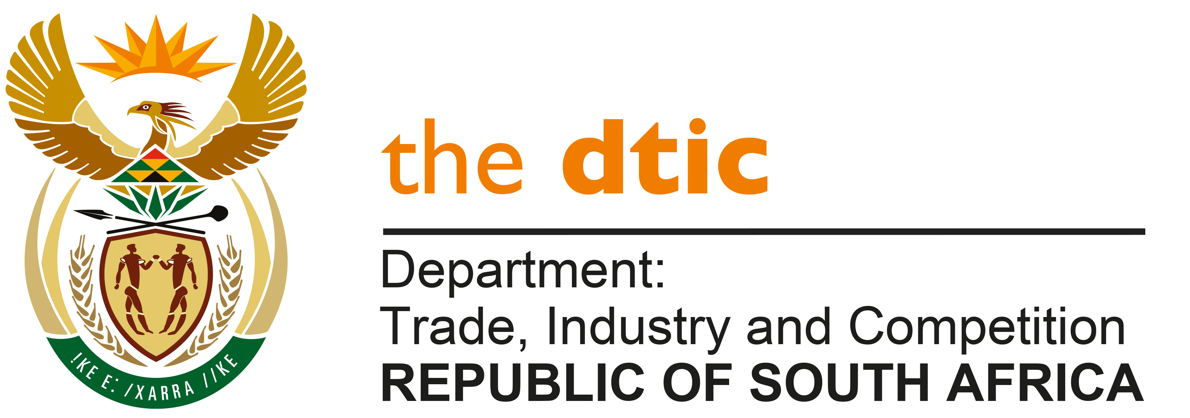

THE NATIONAL ASSEMBLY

QUESTION FOR WRITTEN REPLY

Parliamentary Question 1245

Dated Published: 14 May 2021

Mr M Hlengwa (IFP) to ask the Minister of Trade, Industry and Competition:
Whether his department has taken any formal steps to secure international co-operation on access to patents and technology for the Republic on the production of COVID-19 vaccines; if not, why not; if so, what (a) are the relevant details, (b) inroads have been made and (c) are the challenges? NW1436E

REPLY

Yes, the Department has taken formal steps to secure international cooperation on access to patents and technology for the Republic on the production of Covid-19 vaccines. In October 2020 South Africa and India tabled a proposal at the WTO calling for a temporary waiver of intellectual property rights of certain provisions of the TRIPS Agreement. Work has been done with both DIRCO and with the Department of Science and Innovation. President Ramaphosa has engaged with Heads of State to take forward the proposal for the Waiver.

Equitable vaccine rollout across the world is urgent, necessary and in the interest of people across the world. Reportedly about 75% of the vaccines administered were done in just 10 countries and many countries have not yet received a single dose.

On Wednesday, 14 April 2021, on behalf of the SA Government, I addressed the World Trade Organisation (WTO) on the importance of vaccine equity in the face of the most severe health and economic crisis of our generation. The discussion, which included the trade ministers of India, the European Union and United States, as well the heads of the WTO (Dr Okonjo-Iweala) and World Health Organisation (Dr Adhanom) provided a platform for South Africa to lay out its argument for temporary waiver of key areas of the WTO agreement on Trade-Related Aspects of Intellectual Property Rights (TRIPS).

We pointed out that the world faces a dramatic supply-constraint. At current levels of vaccine production, it may take the world a number of years to bring the virus under control. The gap in availability of supplies will give time for the virus to spread, and to mutate into more deadly or contagious strains. Vaccine nationalism, the race to purchase vaccines by those who can afford them and vaccine hoarding are not a solution to the global supply-constraint. They are pernicious examples of beggar-thy-neighbour policies.

We made the case for stepping up production on-scale. This means using all available capacity and repurposing capacity where this can be done safely and by adhering to necessary standards.

The constraints to scaling up production include technical challenges, inadequate investment to repurpose existing production facilities and the current intellectual property rights regime.

In this context, we called for a ‘Covid New Deal’ to significantly and rapidly increase supply of vaccines and related medical goods and promote more equitable access to such essential goods.

Until the pandemic is brought under control, support for the Waiver will continue to grow.

Voluntary arrangements as provided for in the WTO’s TRIPS Agreement in many cases are simply contract production on a ‘fill and finish’ basis that do not address backward integration and distribution rights; whilst compulsory licensing procedures are onerous and cumbersome.

Negotiations with suppliers are hampered by information and bargaining asymmetries that can result in inequitable outcomes and untenable conditions attached to their procurement.

TRIPS flexibilities were simply not designed to meet the scale of the challenge we now confront.

Based on this, we proposed that the Covid package or New Deal be pursued on parallel and mutually reinforcing tracks, done pragmatically and covering five areas.

First, to scale-up production, in partnership with pharmaceutical companies, that can cover investment and funding to enhance supply capacity in different and additional parts of the world. This necessitates effective transfer of technology, sharing of know-how, backward integration of the raw materials and distribution rights. It must unlock productive capacity not just fill and finish.

Second, a timebound and targeted TRIPS waiver covering only essential diagnostics, vaccines, therapeutics and supplies.

Third, protocols covering transparency of contracts and price stability undertakings.

Fourth, commitment to avoid resort to vaccine nationalism; and

Finally, a TRIPS provision dealing specifically with future pandemics, that provides automatic rights of use and obviates the need for special arrangements and waivers.

Considerable progress has been made to put together a broad coalition of countries in support of the Waiver proposal. Sixty-three WTO Members have co-sponsored the Waiver Proposal and another 50 have indicated their support. There is support across the developing world, and from members of the US Congress, among EU Parliamentarians and from civil society globally. The United States and New Zealand became the first developed countries to support the Waiver. However, not all European countries have as yet supported the proposal for the Waiver put forward by South Africa and India. However, it does seem that all countries are in agreement that the status quo is inadequate and that the WTO will need to find a solution to enable rapid scaling-up of production of vaccines. Discussions are now continuing and South Africa and India together with the other co-sponsors, are engaging more countries to build further support for the proposal for a Waiver.

We have a responsibility imposed by circumstances; and need to build a common approach to act with boldness to save lives.

-END-

