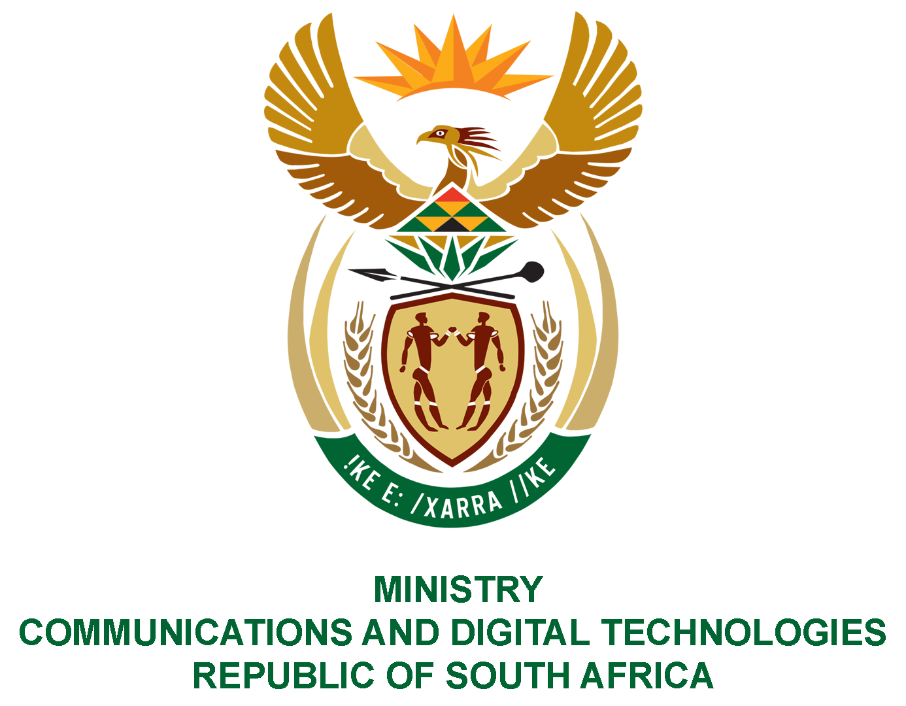

PARLIAMENT OF THE REPUBLIC OF SOUTH AFRICA
NATIONAL ASSEMBLY
WRITTEN REPLY

QUESTION NO: 1245
DATE OF PUBLICATION: July 2020
QUESTION PAPER NO:
Ms Z Majozi (IFP) to ask the Minister of Communications:
- What interventions has she put in place to mediate for the lowering of data costs during the Covid-19 pandemic;
- What number of websites have been zero-rated since the announcement of the first cases of Covid-19 in the Republic over 100 days ago;
- what measures are being taken to ensure that data costs will remain lowered;
- What (a) impact has the Covid-19 pandemic had on the sale of spectrum and (b) measures will be taken to continue driving down costs of data and strengthen bandwidth in the Republic? NW1611E
REPLY
I have been advised by the department as follows:
(1) The Minister of Communications and Digital Technologies issued Electronic Communications, Postal and Broadcasting Directions on 26 March 2020 under the Disaster Management Act. The Minister directed the Independent Communications Authority of SA (ICASA) to assign temporary spectrum to licensed operators in order to amongst others to ensure availability of high-speed data at affordable prices.
(2) There are 988 zero rated websites in South Africa as of 30 July 2020.

(3) As part of the implementation of Competition Commission Data Services Market Inquiry recommendations 2019, the Department of Communications and Digital Technologies is amending the Electronic Communications Act 36 of 2005 and among other issues to formally effect the guidelines on the Zero Rating. Furthermore, to ensure that data costs are lowered, Independent Communications Authority of South Africa’s (ICASA) is conducting the Mobile Broadband Services Inquiry in South Africa to assess the state of competition and determine whether or not there are markets or market segments within the mobile broadband services value chain that may warrant regulation in the context of a market review in terms of the Electronic Communications Act, 2005.
(4) The temporary licensing of all available spectrum bands including the unassigned high demand spectrum for the duration of the Directions issued on 26 March 2020, directed the Authority to relax spectrum regulations to enable COVID-19 national disaster.
ICASA subsequently issued COVID-19 National Disaster Regulations on 6 April 2020 to enable amongst other things the issuing of temporary spectrum licenses. Temporary radio frequency spectrum licenses were subsequently issued that include the obligation to provide data services at a reduced rate to consumers. Other obligations include zero-rating and connecting virtual classrooms free of charge.

MS STELLA NDABENI-ABRAHAMS, MP
MINISTER OF COMMUNICATIONS AND DIGITAL TECHNOLOGIES

