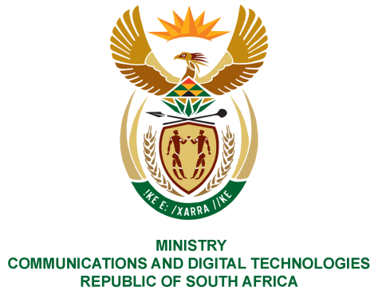

PARLIAMENT OF THE REPUBLIC OF SOUTH AFRICA

NATIONAL ASSEMBLY

WRITTEN REPLY

QUESTION NO: 1244

DATE OF PUBLICATION: 7 May 2021
QUESTION PAPER NO: 13

Ms Z Majozi (IFP) to ask the Minister of Communications and Digital Technologies:
Given current litigation surrounding the auctioning of spectrum, (a) how does the Government intend to ensure availability of high demand spectrum and (b) for how long will such initiatives last? NW1435E

REPLY:
(a)(i) With regards to the pending litigation, the effect of the interdict granted on 8 March 2021, is that the Independent Communications Authority of South Africa (ICASA) is prohibited from proceeding with auctioning the spectrum as planned. The Ministry and the Department of Communications and Digital Technologies remain desirous of the speedy resolution of the matter out of court and continues to support the auctioning of spectrum as government is in dire need of the proceeds that will be derived therefrom. The Ministry and Department respect the interim relief granted by the court and abide thereby. Government can therefore only ensure the availability of high demand spectrum when all parties submit to mediation to resolve the matter out of court or the court rules thereon, whichever comes first.
(a)(ii) As far as it relates to temporary spectrum, the Minister issued the Electronic Communications, Postal and Broadcasting Directions under the Disaster Management Act on 26 March 2020. In terms of the Directions so issued temporary licensing of high demand spectrum must be provided for the duration of the COVID-19 national disaster.

(b)(i) The litigation is set down for hearing on 26 to 29 July 2021 and the Ministry and Department are not in a position to pre-empt the outcome and length thereof.

(b)(ii) ICASA, in its latest amendment of the ICT COVID-19 Regulations (28 May 2021), extended the validity of the temporary radio frequency spectrum licences to 31 August 2021.

MS. STELLA NDABENI-ABRAHAMS, MP
MINISTER OF COMMUNICATIONS AND DIGITAL TECHNOLOGIES

