FOR WRITTEN REPLY QUESTION 1244

NATIONAL ASSEMBLY
36/1/4/1(202000137)

DATE OF PUBLICATION IN INTERNAL QUESTION PAPER: 19 JUNE 2020 IINTERNAL QUESTION PAPER NO 22-2020)

1244. Ms Z Majozl (IFP) to ask the Minister of Police:

What number of new SA Police Service (SAPS) officers have successfully completed training at the latest specified date;

- what number of (a) active members of the SAPS and (b) SAPS reservists have been deployed during the different stages of the period of lockdown to curb the spread of Covid-19:

- whether his department is on track in terms of training and recruitment to strengthen the police force; if not, what is the position in this regard; if so, what are the relevant details;

- what challenges have been experienced in terms of the filling of vacancies, recruitment and training of new SAPS members’7

REPLY:
NW1610E

(1) On 13 December 2019, a total of 4 971 new recruits successfully completed their training.

2(a)(b)
Members of the South African Police Service (SAPS) and reservists were and are still deployed for routine operations, for policing services and the enforcement of the coronavirus (COVID-19) preventative measures. It is preferred/recommended that the figures are not provided, for security reasons.

- The process of finalising the SAPS 2020 Trainee Intake was at an advanced stage. However, it was unfortunately suspended, until further notice, by the Minister of Police, due to the State of National Disaster and subsequent nationwide lockdown, which was announced by the President of the Republic of South Africa, as a result of the COVID-19 pandemic. The recruitment plan of the SAPS is currently being reviewed,

2

in order to respond to the COVID-19 restrictions put in place, such as social distancing, restriction/suspension of large gatherings/meetings, etc..

- The filling of other vacancies in the SAPS is continuing, however, it has not been po9sible to enlist new SAPS member6 to report for training at the various training academies in the country, due to the COVID-19 restrictions and protocols (social distancing, large gatherings/meetings, physical training, etc)

Reply to question 1244 recommended

CO
KJ LE (SOEG)
GENERAL

UTH AFRICAN POLICE SERVICE

Reply to question 1244 approved/not approved
0
0
v

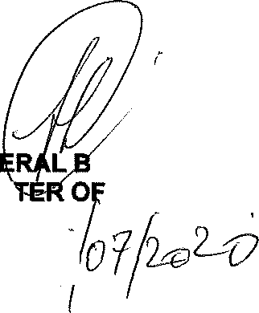GEN MINIS”
Date: @
H CELE (MP)

POLICE

