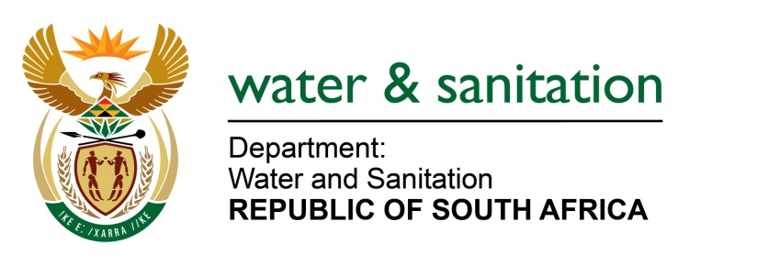

NATIONAL ASSEMBLY

FOR WRITTEN REPLY

QUESTION NO 1244

DATE OF PUBLICATION IN INTERNAL QUESTION PAPER: 12 MAY 2017
(INTERNAL QUESTION PAPER NO. 16)

1244. Mr L J Basson (DA) to ask the Minister of Water and Sanitation:
(1) Whether any new employment positions were created in the Office of the Director-General of her department since 1 April 2016; if so, (a) why, (b) which positions were created, (c) who was appointed to each position and (d) what are the terms of their employment;
(2) whether she intends to create any new employment positions in the specified Office in the next six months; if so, (a) why and (b) what are the further relevant details;
(3) whether any vacant, newly created and/or intended employment positions have been advertised; if so, (a) which employment positions, (b) when was the position advertised and (c) what are the minimum requirements for each position? NW1386E
---00O00---
REPLY:
- There are no new positions created in the office of the Director-General since 01 April 2016.

- There are no intentions of creating any new employment positions in the office of the Director-General in the next six months. The preliminary finding from the structure review process has indicated the reduction in the number of employment positions in the office of the Director-General. This preliminary finding is supported by the business process mapping.

- No newly created employment positions were advertised.
---00O00---

