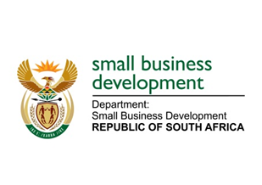
NATIONAL ASSEMBLY
QUESTION FOR WRITTEN REPLY
DUE TO PARLIAMENT: TUESDAY, 19 APRIL 2022

1242. Mr D F Mthenjane (EFF) to ask the Minister of Small Business Development:
What (a) number of women-owned businesses have been supported by her department in the three quarters of the 2020-21 financial year and (b) lessons has her department learnt in this regard? NW1498E

REPLY: I have been advised by the department as follows:

- As per the published audited 2020/21 Annual Report of the Department of Small Business Development (DSBD), the Department supported 1 015 women-owned businesses during 2020/21 financial year.
- The lessons learnt in this regard is that the DSBD should consider designing support programmes which are targeted specifically for vulnerable groups such as women, youth and people with disabilities as these groups are still operating in the informal or micro level and mostly vulnerable to disasters and externalities. The department will also have to collaborate and partner with other entities within government in the private sector to leverage on existing resources and capacity. According to a study conducted in collaboration with the World Bank, women owned businesses have received between 13,8 % and 34% of government support during the different levels of COVID-19 lockdown.

STELLA NDABENI-ABRAHAMS
MINISTER: SMALL BUSINESS DEVELOPMENT

