MINISTRY OF DEFENCE & MILITARY VETERANS

NATIONAL ASSEMBLY

QUESTION FOR WRITTEN REPLY

1241. Mr S J F Marais (DA) to ask the Minister of Defence and Military Veterans:
(1) Whether, with reference to her reply to question 665 on 13 April 2018, she has found that the old structure used by Armscor to respond to the demands of her department was insufficient; if so, what are the relevant details;
(2) (a) will she provide a (i) detailed comparison between the old and the new structure, (ii) list of the demands and indicate if the demands are new or additional demands and (iii) detailed list of the new demands and (b) how will the new demands benefit Armscor and her department;
(3) with reference to each general manager and chief executive officer (CEO) in the new structure, what (a) additional responsibilities were added to the job description of each, (b) were the percentage increases, (c) are the details of the previous total cost-to-company and current total cost-to-company remuneration packages paid to each and (d) were the last performance bonuses paid to each general manager and the CEO? NW1340E

REPLY:

665 Response: Armscor implemented an efficient structure in order to respond to the objective of the Armscor Act, respond to the demands of the Department of Defence, to be cost-effective and to achieve its Turnaround Strategy. A benchmarking study with similar organisations and state owned enterprises such as Council for Scientific and Industrial Research (CSIR), South African Nuclear Energy Corporation (NECSA) was undertaken.

The restructuring of the executive management took into consideration the delegation and accountability by streamlining and strengthening the executive decision-making to create fewer executive committee members with broader spans of control. Price Waterhouse Coopers (PWC) benchmarked the recommended remuneration and approval by the Board of Directors was obtained. No budgets were increased to fund new salaries and market benchmarks placed the salaries at the lower pay scale quartile which is below midpoint for executive management.

New Response: The old structure had limited capacity to respond to the demands of the DOD as well as the new business endeavours for revenue generation as per the Turnaround Strategy whilst providing effective and efficient service to the DOD.

QUESTION 2
Will she provide a (i) detailed comparison between the old and the new structure, (ii) list of the demands and indicate if the demands are new or additional demands and (iii) detailed list of the new demands and (b) how will the new demands benefit Armscor and her department;

RESPONSE

Figure 1: Old Structure

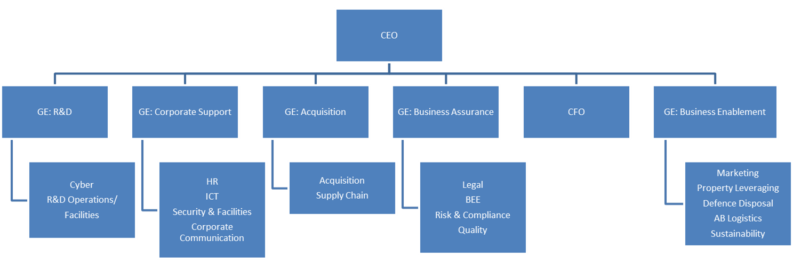

Figure 2: New Structure

The new structure provides for a wider span of control, leaner executive body to drive quick decision-making across the organisation, broader scope of services and devolution of authority. This has assisted in removing fragmentation and duplication of activities across the organisation. This has resulted in clear reporting lines and clear single person accountability thus expediting operational execution. This allows for a more focused organisation in delivering to its demands of the DOD and its new commercial imperatives. The new commercial imperatives relate to the strategic objectives of the Turnaround which are revenue generation, cost savings, efficient and efficient delivery and stakeholder engagement.

QUESTION 3

With reference to each general manager and chief executive officer (CEO) in the new structure, what (a) additional responsibilities were added to the job description of each, (b) were the percentage increases, (c) are the details of the previous total cost-to-company and current total cost-to-company remuneration packages paid to each and (d) were the last performance bonuses paid to each general manager and the CEO?

RESPONSE
The new structure entailed more responsibilities per Group Executive, combination of similar functions and centralising of the Supply Chain Management with the Acquisition function in order to ensure strategic sourcing and smart buying. The new executives who received promotions were benchmarked against the market and capped at 37.5th percentile of the market which is the lower quartile. Given the fact that the Board took a decision not to extend normal annual increase inflationary adjustment to all the GE’s who were promoted as a result of the restructuring, the real increase for the GE level amounted to 13% (factoring 0% annual increase). All new executives’ performance bonuses were capped at maximum of 8% for the last financial year. This equates to an extra months’ salary.

