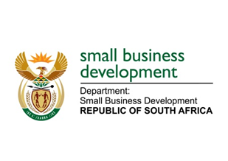
NATIONAL ASSEMBLY
QUESTION FOR WRITTEN REPLY
DUE TO PARLIAMENT: FRIDAY, 14 APRIL 2023

“1234. Mr J N de Villiers (DA) to ask the Minister of Small Business Development:
Whether she will provide a comprehensive list of businesses in each province that have received support from the (a) Small Enterprise Finance Agency and (b) Small Enterprise Development Agency in the past financial year; if not; why not; if so, what are the relevant details?” NW1375E

REPLY:

(a)&(b) It should be emphasised that in respect of the Department of Small Business Development (DSBD) and its entities, the Small Enterprise Development Agency (Seda) and the Small Enterprise Finance Agency (sefa), sharing personal information related to the businesses supported during 2022/23 financial year, meeting the requirements of the Protection of Personal Information Act No. 4 of 2013 is mandatory. A key objective of the Act is to protect people from harm by protecting their personal information. Also, it is to ensure that personal information is only allowed to be processed if the end-user consents to the processing, including the specific purposes for which the personal information is being collected. Therefore, the expectation is that Honourable J.N. de Villiers and the Questions Office in Parliament will handle the provided lists in a manner that is compliant with the Act.

The attached lists reflect details of the businesses supported in each province by the Department, through Seda and sefa during 2022/23 financial year.

