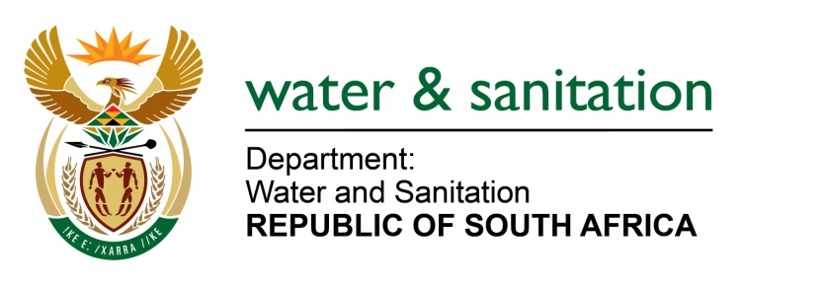

NATIONAL ASSEMBLY

FOR WRITTEN REPLY

QUESTION NO 1234

DATE OF PUBLICATION IN INTERNAL QUESTION PAPER: 06 MAY 2016
(INTERNAL QUESTION PAPER NO. 13)

1234. Mr A R McLoughlin (DA) to ask the Minister of Water and Sanitation:

(1) Whether, with reference to particular key commitments undertaken by her as a consequence of the assessment of her department by the Auditor-General in the 2014-15 financial year, the focus risk assessment has been discussed by her department’s top management; if not, why not; if so, (a)(i) when and (ii) where did such discussions take place, (b) who was present during the specified discussions and (c) what was the outcome of the discussions;

(2) whetherher department’s audit committee produce a report on its monitoring of the risk assessment; if not, (a) why not and (b) when will this take place;

(3) whether, with reference to the specified commitments, a structure incorporating the sanitation function has been established; if not, why not; if so, what (a) is the name of the specified structure, (b) are the full relevant details of the terms of reference of the specified structure, (c) sanitation-related work has the specified structure undertaken to date and (d) were the outcomes in each case;

(4) whether, with reference to the specified commitments, a joint team comprising her department, the Auditor-General of South Africa and the National Treasury has met to commence its work towards addressing issues of concern; if not, why not; if so, what are the relevant details? NW1382E
---00O00---
REPLY:
(1)(a)(i) My Department's Top Management discussed the Auditor-General (AG)’s report on the following dates, refer below:
- 13 October 2014;
- 23 February 2015; and
- 23 March 2015.

Furthermore the Risk Management Committee also discussed the AG's report on 13 October 2014.

(1)(a)(ii) The meeting took place in Pretoria.

(1)(b) The meeting was attended by members of Top Management and Risk Management.

(1)(c) The outcomes of the discussions was to mitigate risks as identified by the AG and to continue to improve the internal control environment.
(2) My Department’s audit committee report has been included in the annual report for 2014/15 financial year.
(3) No, the structure of the sanitation function remains as transferred from the Department of Human Settlements. The organisational structure of my Department is currently being reviewed in its entirety.
(4) A Steering Committee functions within my Department and is attended by Top Management, Internal Control, AG and National Treasury, which worked in tandem to resolve the issues raised during the AG Audit.
---00O00---

