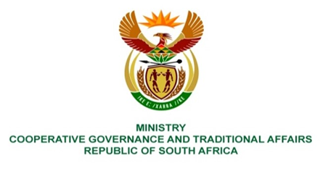

NATIONAL ASSEMBLY
WRITTEN
QUESTION NUMBER 1229
DATE OF PUBLICATION: 01 APRIL 2022
QUESTION:
1229. Mr K Ceza (EFF) to ask the Minister of Cooperative Governance and Traditional Affairs:
What action has been taken by her department to compel provinces and municipalities who are sitting on section 106 reports to submit such reports? NW1485E

REPLY:
The Department engages with provinces and municipalities through correspondences and meetings to ensure that they submit such copies of investigation reports conducted in line with Section 106 of the Local Government Municipal Systems Act, 2000. The Department continues to collaborate with law enforcement agencies and provinces through the recently established Local Government Anti-Corruption Forum (LGACF) to ensure the implementation of recommendations emanating from such investigation reports. Amongst others, the formation of the LGACF is vital for the purpose of fostering collaboration amongst the stakeholders at the local government level in order to effectively prevent corruption and coordinate efforts amongst all the key stakeholders including law enforcement agencies.
Further, if the Honourable Member is aware of such a report/s which have not been shared with the Department or law enforcement agencies, the Honourable Member is requested to provide more details so that officials from the Department can follow up on the matter.

