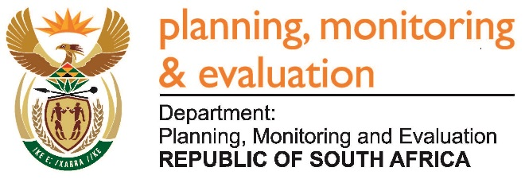 |  | 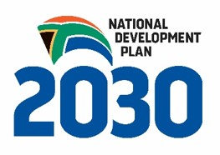
Private Bag X944, PRETORIA, 0001. Union Buildings East Wing, Government Avenue, PRETORIA
Tel: 012 312 0307. www.dpme.gov.za

1228. Mr M W Rabotapi (DA) to ask the Minister in The Presidency:

Whether (a) his Office and (b) each entity reporting to him has (i) procured any services from and/or (ii) made any payments to the Decolonisation Foundation; if not, in each case, what is the position in this regard; if so, what (aa) services were procured, (bb) were the total costs, (cc) is the detailed breakdown of the costs, (dd) was the total amount paid, (ee) was the purpose of the payments and (ff) is the detailed breakdown of the payments in each case? NW1369E

REPLY:

No.

