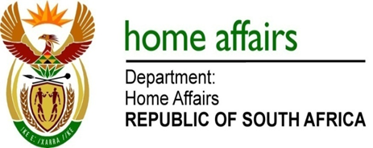

NATIONAL ASSEMBLY

QUESTION FOR WRITTEN REPLY

QUESTION NO. 1222

DATE OF PUBLICATION: Monday, 15 May 2017

INTERNAL QUESTION PAPER 16 OF 2017

1222. Mr S Mokgalapa (DA) to ask the Minister of Home Affairs:

Whether (a) her department and (b) each entity reporting to her has (i) procured any services from and/or (ii) made any payments to the Decolonisation Foundation; if not, in each case, what is the position in this regard; if so, what (aa) services were procured, (bb) were the total costs, (cc) is the detailed breakdown of the costs, (dd) was the total amount paid, (ee) was the purpose of the payments and (ff) is the detailed breakdown of the payments in each case? NW1363E
REPLY:

The question was forwarded to the Department and the entities who responded as follows:

- Department of Home Affairs
The Department has not procured any services from or made any payments to an entity called the Decolonisation Foundation as there has been no need to do so.

- Government Printing Works
Government Printing Works has not procured any services from or made any payments to an entity called the Decolonisation Foundation.

- Electoral Commission
The Electoral Commission has not procured any services from or made any payments to an entity called the Decolonisation Foundation, and none are expected to be procured.

