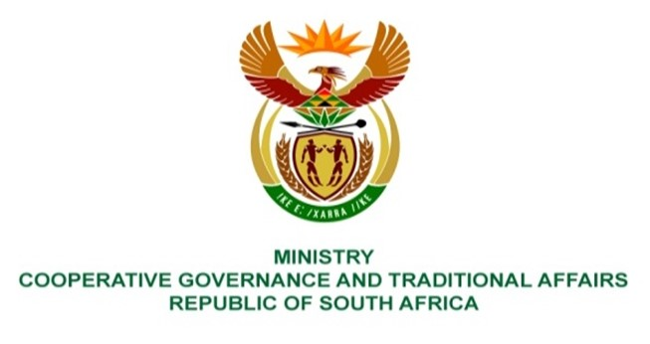

NATIONAL ASSEMBLY
WRITTEN
QUESTION NUMBER 1215
DATE OF PUBLICATION: 01 APRIL 2022

QUESTION:

1215. Mr I M Groenewald (FF Plus) to ask the Minister of Cooperative Governance and Traditional Affairs:
(1) With regard to the implementation and roll-out of the District Development Model (DDM) policy, (a) what total amount has been spent to date, (b) at which districts have the money been spent and (c) on which particular DDM projects have the money been spent;
(2) whether she will make a statement on the matter? NW1468E

REPLY:

(1) The District Development Model (DDM) approach was approved by Cabinet in August 2019. Cabinet also approved that the DDM should be piloted in three areas, namely eThekwini (Kwa-Zulu Natal), OR Tambo (Eastern Cape) and Waterberg (Limpopo). Subsequently, the Department of Cooperative Governance (DCOG) entered into a Memorandum of Understanding with the Development Bank of Southern Africa (DBSA) on 3 March 2020 to act as the implementing agent to the department for the establishment of the Programme Management Office (PMO) and rolling out Phase 1 of the DDM in the three pilots.
(a) The total actual expenditure incurred as at 28 February 2022 amounted to R88,2 million.
(b) The funding was spent on the establishment of the PMO and the three pilot districts, namely eThekwini, OR Tambo and Waterberg.
(c) The following DDM projects were funded from the expenditure mentioned in (a) above:
- Establishment of the PMO (staffing and operational costs);
- Establishment of the three pilot hubs (staffing and operational costs);
- Strengthening the capacity of the National Disaster Management Centre (staffing costs);
- Development of the One Plans for the three pilots;
- Integrated Urban Development Framework (IUDF) – development of four (4) Capital Expenditure Frameworks and five (5) Infrastructure Asset Management Plans for identified Intermediate City Municipalities;
- Development of the National Local Economic Development Implementation Plan;
- Conducting of a feasibility study for the implementation of Shared Services in OR Tambo and Waterberg pilots;
- Development of the DDM Integrated Monitoring and Evaluation Framework and associated draft Process and Procedure Manual; and
- Development of the DDM Information Management System solution architecture, cloud hosting environment and One Plan prototype.

(2) No, the Minister does not intend to make statement on the matter.

