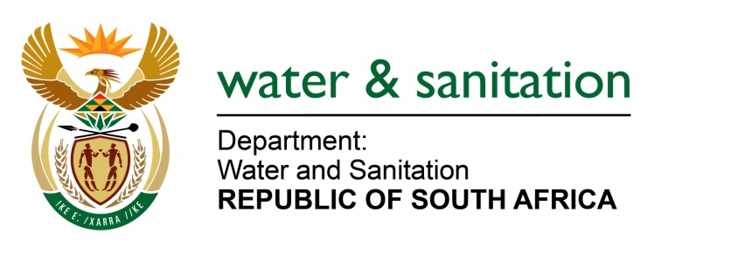

NATIONAL ASSEMBLY

FOR WRITTEN REPLY

QUESTION NO 1214

DATE OF PUBLICATION IN INTERNAL QUESTION PAPER: 31 MARCH 2023
(INTERNAL QUESTION PAPER NO. 12)

1214. Ms S J Graham (DA) to ask the Minister of Water and Sanitation:
(1) What (a) total number of boreholes for the provision of water are in each town in the Dr Beyers Naudé Local Municipality, (b) number of the boreholes are not working optimally, (c) are the plans have been put in place for the repairs to the boreholes that are not working, (d) are the time frames for the repairs to restore the boreholes to operation.
(2) whether the telemetry system for each town is fully operational; if not, why not; if so, what are the water losses recorded and reported by the municipality?
NW1355E
---00O00---

MINISTER OF WATER AND SANITATION

1. The details for boreholes in the Dr Beyers Naudé Local Municipality are indicated in the table below:

Town | - Total number of boreholes | Operational | (b) Non-operational boreholes and reasons thereof | (c) Plans in place | (d) Timeframe for repairs
Graaff-Reinet | 42 | 39 | 3 - due to flooding – electrical damage: | To be replaced by municipality when budget is available | 2023-24 financial year
Nieu-Bethesda | 4 | 4 | 0 | NA | NA
Aberdeen | 13 | 13 | 0 | NA | NA
Steytlerville | 4 | 3 | 1 - Borehole motor needs repairs: | In process to be replaced when budget is available | 4 months: Depending on budget availability.
Willowmore | 13 | 10 | 3 | testing of boreholes underway | Approximately 2 months for testing results
Jansenville | 9 | 6 | - 1 - borehole flooded resulting in electrical damage.  - 1 – borehole functionality has deteriorated  - 1 borehole not equipped | - Awaiting disaster management funding  - Testing of borehole in new financial year. | - 2023-34 financial year
Klipplaat | 3 | 1 | 2 - Lightning protection on boreholes is problematic | New financial year in line with | municipality fiscal year
Muller | 2 | 2 | 0 | NA | NA
Vondeling | 1 | 1 | 0 | NA | NA
Wolwefontein | 1 | 1 | 0 | NA | NA
Baviaanskloof | 2 | 2 | 0 | NA | NA
Waterford |  |  | 0 | NA | NA
Rietbron | 3 | 3 | 0 | NA | NA

2. The telemetry system is only functional in Graaff-Reinet. The municipality has plans in place to install / upgrade telemetry in all the other towns. The department has been informed that the plans to install or upgrade telemetry systems are dependent on budget availability in the 2023/24 financial year. Non-revenue water, is currently at 37% due to:
- non-payment by users for water
- incorrect metering
- no metering (unmetered connections),
- unforeseen pipe bursts, illegal connections
- real water losses.

---00O00---

