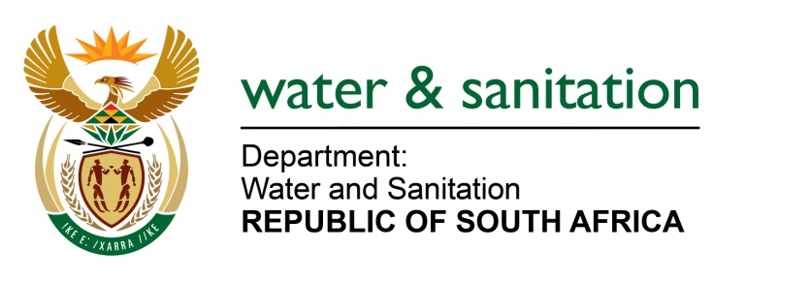

NATIONAL ASSEMBLY

FOR WRITTEN REPLY

QUESTION NO 1211

DATE OF PUBLICATION IN INTERNAL QUESTION PAPER: 22 APRIL 2016
(INTERNAL QUESTION PAPER NO. 12)

1211. Ms T E Baker (DA) to ask the Minister of Water and Sanitation:

Whether her department has received water-use licence applications from the SA National Roads Agency for its proposed infrastructure projects to (a) widen the road from Mtunzini to Empangeni and (b) construct interchanges at Eteza and Kwabhoboza in KwaZulu-Natal; if so, (i) what volume of water is requested in each case and (ii) what sources will be used? NW1351E
---00O00---
REPLY:

(a) South African Roads Agency Limited (SANRAL) was issued a water use licence by the Department for the N2 Mthuzini to Empangeni Junction upgrade on 20 October 2015 for Section 21(c) for impeding and diverting a flow of water in a watercourse and for Section 21(i) for altering the bed, bank and the characteristics of a watercourse.

(b)(i) SANRAL was granted a verbal agreement that they were going to get the water for construction activities directly from uMhlathuze Water, however, due to the drought in KwaZulu-Natal the agreement for clean water supply fell away.

(b)(ii) Murray and Roberts (Pty) Ltd was given the contract for the upgrade of the N2 have submitted a water use authorisation application for taking 40m³/day of water in terms of Section 21(a) of the National Water Act, Act no. 36 of 1998, from the Mhlathuze River for the duration of the construction project. The application was submitted on 15 April 2016.

---00O00---

