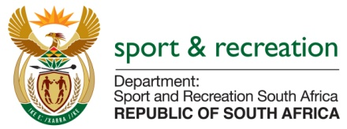

PARLIMENTARY QUESTION FOR THE MINISTER

QUESTION NUMBER 1210

1210. Mr M S Malatsi (DA) to ask the Minister of Sport and Recreation:

What total amount in rands will be paid to each member of the (a) men’s, (b) women’s and (c) under 23 national soccer teams as daily allowances and/or stipends for the duration of their stay in camp during their preparations for the qualifying matches for the 2016 Rio Olympics? NW1350E

REPLY
Awaiting information from SAFA.the information is not readily available.

