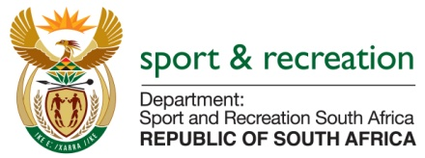

PARLIMENTARY QUESTIONS FOR THE MINISTER

1209. Mr M S Malatsi (DA) to ask the Minister of Sport and Recreation:

What is the total amount in rand payable by the SA Football Association as match fees to members of the (a) men’s, (b) women’s and (c) under-23 national soccer teams for (i) Olympic qualifying matches and (ii)(aa) winning, (bb) drawing and/or (cc) losing any match? NW1349E
REPLY
We are still sourcing information from SAFA (South African Football Association) in this regard

