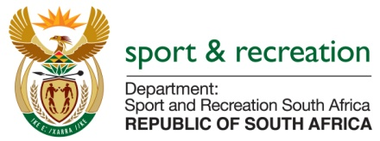

PARLIMENTARY QUESTION FOR THE MINISTER

QUESTION NUMBER 1208

1208. Mr M S Malatsi (DA) to ask the Minister of Sport and Recreation:
(1) What is the total remuneration package in rand payable by the SA Football Association to each coach of the national (a) men’s, (b) women’s and (c) under-23 national soccer teams;
(2) whether each of the total remuneration packages includes any bonuses for (a) winning and/or (b) drawing matches; if not, what is the position in this regard; if so, what are the relevant details in each case? NW1348E

REPLY
Awaiting information from SAFA.the information is not readily available.

