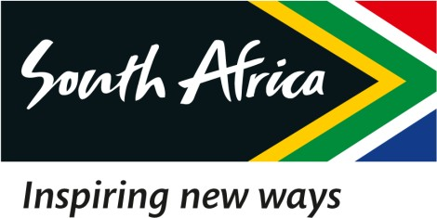

23 March 2023

EXTRACT OF THE DRAFT MINUTES OF THE SPECIAL BOARD MEETING OF THE SOUTH AFRICAN TOURISM, HELD ON 23 MARCH 2023

2.1 Response to the letter from the Minister regarding the Tottenham Deal

RESOLVED that:

Resolution Number: 23/03/23 – BOARD-053 RESOLVED that:

Malatje & Co Attorneys is hereby mandated to draft an interim response to the Hon Minister’s Letter by 21h00 today, for perusal by the Board and thereafter for onward submission to the Hon Minister, to reach her before the scheduled Press Conference at 11h00.

Certified a true extract of the Minutes.

23 March 2023

____________________ ______________

Dr. T Botha Date

Chairperson of the Board

