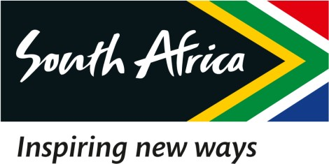

10 February 2023

EXTRACT OF THE DRAFT MINUTES OF THE SPECIAL BOARD MEETING OF THE SOUTH AFRICAN TOURISM, HELD ON 10 FEBRUARY 2023

2.2 Released press statement by the Minister on the Interim CFO

RESOLVED that:

Resolution Number: 10/02/23 – BOARD-040 RESOLVED that:

Management is hereby required to perform a deep dive into crafting a Communications Strategy that would form part of the APP. [Action: COO]

Certified a true extract of the Minutes.

10 February 2023

____________________ ______________

Dr. T Botha Date

Chairperson of the Board

