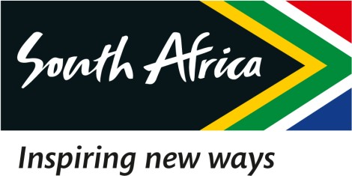

1 March 2023

EXTRACT OF THE DRAFT MINUTES OF THE SPECIAL BOARD MEETING OF THE SOUTH AFRICAN TOURISM, HELD ON 1 MARCH 2023

2.2 Letters of Demand

RESOLVED that:

Resolution Number: 01/03/23 – BOARD-052 RESOLVED that:

The SAT Legal Team engages Malatje Attorneys concerning the Letters of Demand received by the Chairperson of the Board regarding the alleged defamation suit and shall include the Chairperson, ACEO, CoSec, and the GM: PR and Comms, in considering the matter and mapping the way forward.

Certified a true extract of the Minutes.

1 March 2023

____________________ ______________

Dr. T Botha Date

Chairperson of the Board

