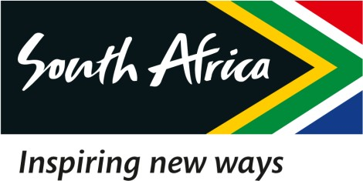

16 February 2023

EXTRACT OF THE DRAFT MINUTES OF THE SPECIAL BOARD MEETING OF THE SOUTH AFRICAN TOURISM, HELD ON 16 FEBRUARY 2023

2.6 ITB Berlin

RESOLVED that:

Resolution Number: 16/02/23 – BOARD-049 RESOLVED that:

The Chairperson of the Board is hereby mandated to nominate Board Members for travel to international events on a rotational basis.

Certified a true extract of the Minutes.

16 February 2023

____________________ ______________

Dr. T Botha Date

Chairperson of the Board

