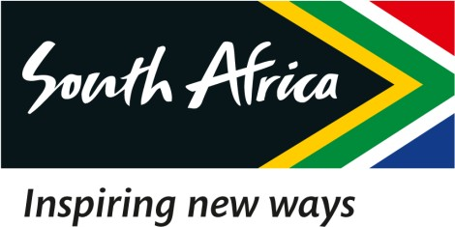

16 February 2023

EXTRACT OF THE DRAFT MINUTES OF THE SPECIAL BOARD MEETING OF THE SOUTH AFRICAN TOURISM, HELD ON 16 FEBRUARY 2023

2.1 Interim CFO and the Way Forward

RESOLVED that:

Resolution Number: 16/02/23 – BOARD-045 RESOLVED that:

Malatje & Co Attorneys is hereby mandated to respond to Webber Wentzel concerning the letter received on behalf of Mr. Johan van der Walt on 16 February 2023 and that Malatje & Co Attorneys be provided with a chronological sequence of events around the Interim CFO matter.

Resolution Number: 16/02/23 – BOARD-046 RESOLVED that:

The immediate appointment of Mr. Themba Ndlovu as Acting Chief Financial Officer (ACFO), is hereby approved.

The Remuneration for the ACFO per the SA Tourism Policy, is hereby approved.

The appointment of a Quality Assurance Director from any of the Members of the Internal Audit Panel, notwithstanding the to-be-appointed ACFO is not a CA (SA), to ensure quality and compliance of South African Tourism Annual Financial Statements, is hereby approved.

Certified a true extract of the Minutes.

16 February 2023

____________________ ______________

Dr. T Botha Date

Chairperson of the Board

