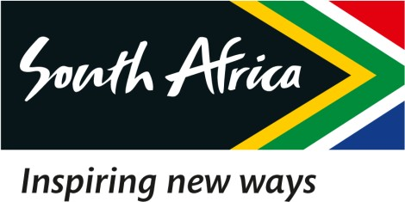

24 March 2023

EXTRACT OF THE DRAFT MINUTES OF THE SPECIAL BOARD MEETING OF THE SOUTH AFRICAN TOURISM, HELD ON 24 MARCH 2023

2.1 Response to the media briefing by the Hon Minister of Tourism regarding the

Tottenham Hotspurs deal

RESOLVED that:

Resolution Number: 24/03/23 – BOARD-054 RESOLVED that:

(1) Malatje & Co Attorneys is hereby mandated to draft a final response to the Minister’s Letter by 13h00 on 27 March 2023, for perusal by the Board and thereafter for onward submission to the Minister before the set deadline of 29 March 2023.

(2) The Acting Chief Executive Officer is hereby required to provide the Close-out Report with all stakeholder engagements by 08h00 on 27 March 2023.

(3) The response to the Hon Minister must clearly articulate the sole source or single source supplier issue, as well as the unsolicited bid and the budgeting of the transaction and amount in the 2022/2023 APP concerning the proposed Tottenham Hotspurs deal.

Certified a true extract of the Minutes.

24 March 2023

____________________ ______________

Dr. T Botha Date

Chairperson of the Board

