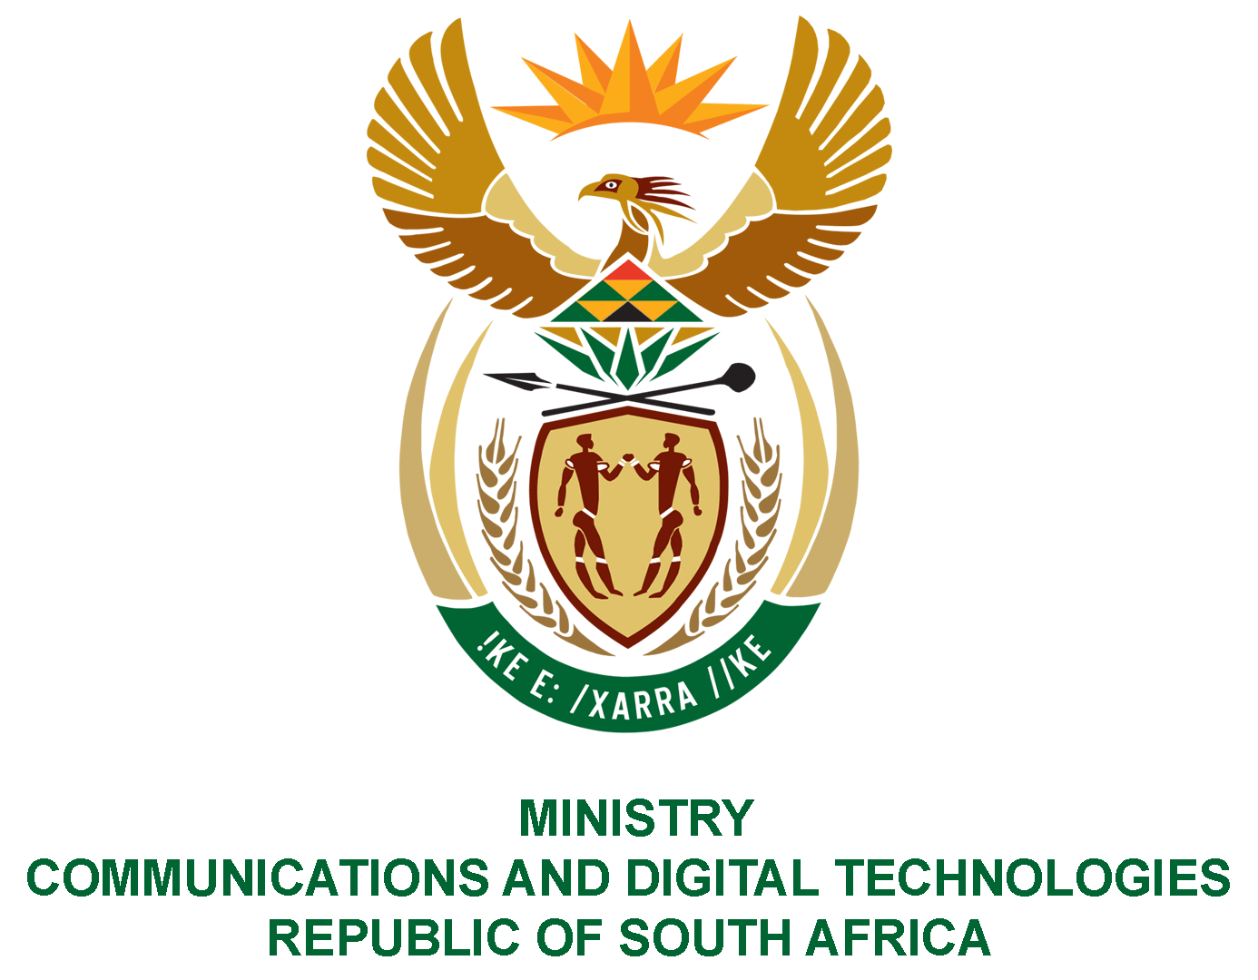

PARLIAMENT OF THE REPUBLIC OF SOUTH AFRICA
NATIONAL ASSEMBLY
WRITTEN REPLY
QUESTION NO: 1207
DATE OF PUBLICATION: 13 JUNE 2020
QUESTION PAPER NO: 20

Mr C MacKenzie (DA) to ask the Minister of Communications:
(1) Whether the Government interacted with certain companies (Huawei, Nokia, Ericsson) that are suppliers of 5G equipment; if not, what is the position in this regard; if so, what was the nature of the specified engagement;
(2) Whether Government has indicated a preference for any of the specified suppliers; if not, what is the position in this regard; if so, why?
NW1512E
REPLY:

I have been advised by the department as follows: -

- The department engages with these companies on an ad hoc basis to discuss among other issues, the following:

- Small, Medium and Micro-sized Enterprise (SMME) development;
- Skills development; and,
- Technology trends.

There has been on-going engagement with Ericsson regarding innovation. Furthermore, the department has engaged Huawei on skills development and participated at its workshop.

(2) The SA Government has no preference of supplier, hence the methodology by mobile operators to utilise a multi-vendor approach in their roll-out.

MS. STELLA NDABENI-ABRAHAMS, MP
MINISTER OF COMMUNICATIONS AND DIGITAL TECHNOLOGIES

