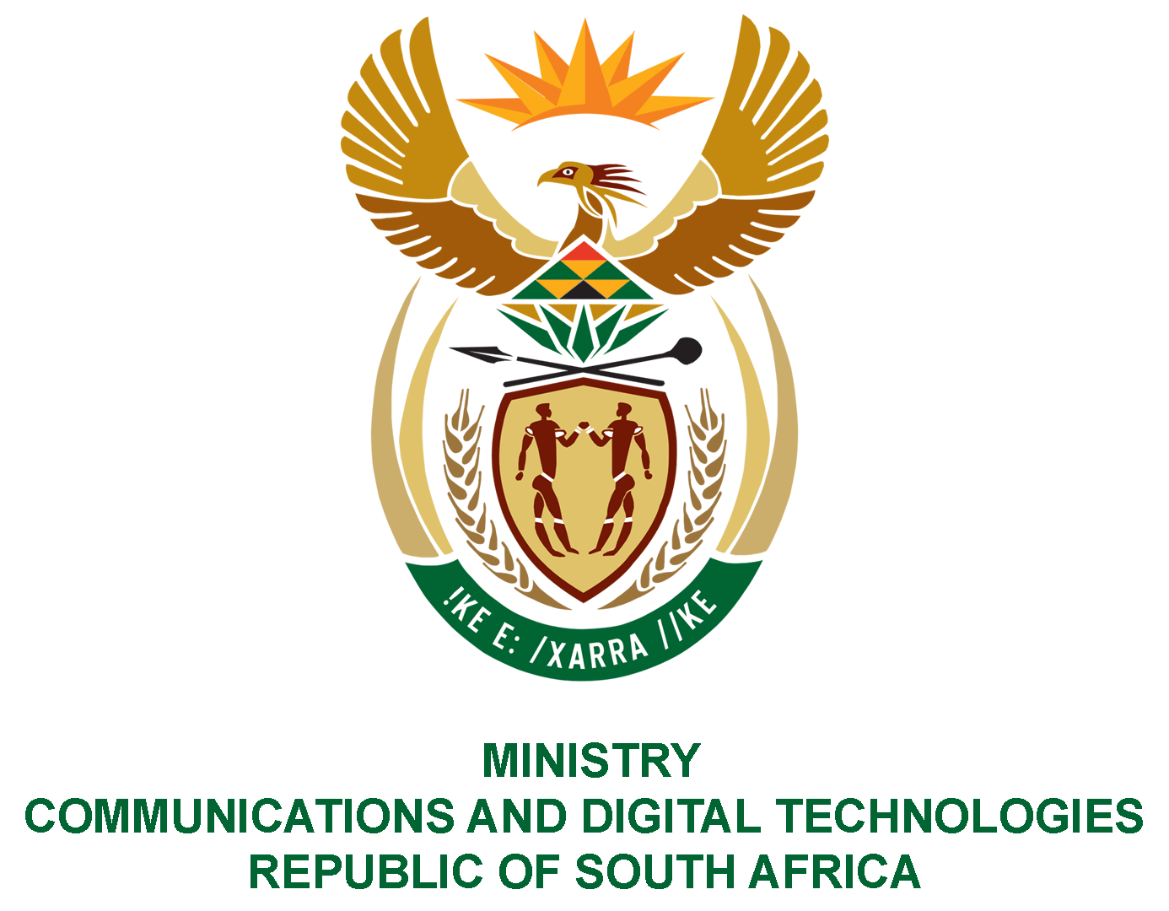

PARLIAMENT OF THE REPUBLIC OF SOUTH AFRICA

NATIONAL ASSEMBLY

WRITTEN REPLY

QUESTION: 1201

DATE OF PUBLICATION: 1 April 2021
QUESTION PAPER NO: 13

Mr M S Malatsi (DA) to ask the Minister of Communications and Digital Technologies:
- What amount did (a) the Independent Communications Authority of South Africa, (b) Sentech, (c) the Universal Service and Access Agency of South Africa and/or Universal Service and Access Fund (d) Film and Publication Board, (e) Government Communication and Information Systems and (f) Media Development and Diversity Agency spend on (i) settlements and (ii) salaries to spend on (i) settlements and (ii) salaries to suspended employees in the past eight financial years;
- What were the reasons for each suspension? NW1325E

REPLY:
I have been advised by the SOEs as follows:
1.
SOEs | - Settlements | (ii) Salaries to suspended employees
- ICASA | R1,098 751.50 | R3 041 738.20
- Sentech | R299 090.06 | R1 557 694.72
c) USAASA | - | R 1 521 3834.00
- FPB | R3 320 804.52 | R1 337 956.81
- GCIS | The question pertaining to the GCIS and MDDA should be directed to the Minister in the Presidency as these entities fall within his portfolio.
- MDDA

2. The responses are provided in the attached annexure.

Authorised for submission by

MS. NONKQUBELA JORDAN-DYANI
DIRECTOR-GENERAL (ACTING)
DATE:

Recommended/not recommended

__________________________
HON. PHILLY MAPULANE, MP
DEPUTY MINISTER OF COMMUNICATIONS AND DIGITAL TECHNOLOGIES
DATE:

Approved/ not approved

________________________________
HON. KHUMBUDZO NTSHAVHENI, MP
MINISTER OF COMMUNICATIONS AND DIGITAL TECHNOLOGIES
DATE:

