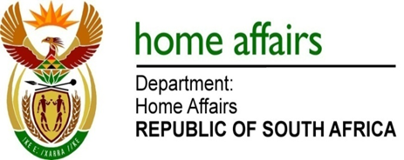

NATIONAL ASSEMBLY

QUESTION FOR WRITTEN REPLY

QUESTION NO. 12

DATE OF PUBLICATION: THURSDAY, 20 JUNE 2019

INTERNAL QUESTION PAPER 1 OF 2019

12. Ms L L van der Merwe (IFP) to ask the Minister of Home Affairs:

(a) What is the current total number of documented asylum seekers in the Republic and (b) from which countries are they? NW960E

REPLY:

- The total number of active asylum seekers (section 22 permit valid) as at 31 December 2018 is 184 976.

- They are from the following countries:

Countries | Total
Ethiopia | 50135
DRC | 34754
Bangladesh | 27243
Zimbabwe | 14861
Pakistan | 9383
Congo | 8626
Nigeria | 6781
Burundi | 6425
Uganda | 4461
India | 4267
Somalia | 4152
Malawi | 2175
Ghana | 2032
Cameroon | 1767
Kenya | 1081
Rwanda | 1015
Eritrea | 978
Senegal | 899
Niger | 818
Mozambique | 648
Tanzania | 605
Zambia | 264
Egypt | 227
Ivory Coast | 183
Algeria | 167
China | 126
Mali | 120
Nepal | 88
Liberia | 70
Sudan | 57
Benin | 55
Lesotho | 53
Guinea | 52
Burkina Faso | 44
Thailand | 31
Togo | 30
Syria | 25
Comoros | 23
Swaziland | 17
Gabon | 16
Afghanistan | 16
Sierra Leone | 15
Yemen | 14
Bahamas | 14
Sri Lanka | 13
Palestine | 12
Gambia | 11
Guinea Bissau | 10
Morocco | 9
East Timor | 8
Estonia | 8
Angola | 7
Iraq | 6
Chad | 6
Central African Republic | 6
Jordan | 6
Bahrain | 5
Turkey | 5
Ukraine | 4
Botswana | 3
Hungary | 3
Mauritania | 3
Other | 3
Libya | 3
Denmark | 2
Jamaica | 2
Madagascar | 2
Malaysia | 2
Venezuela | 2
Mauritius | 2
Iran | 2
Solomon Islands | 2
Paraguay | 1
New Zealand | 1
Namibia | 1
Suriname | 1
Azerbaijan | 1
Colombia | 1
Wallis and Futuna | 1
Kyrgyzstan | 1
Uruguay | 1
Myanmar (Burma) | 1
Bosnia | 1
Ireland | 1
Haiti | 1
Russia | 1
Barbados | 1
Lebanon | 1
Grand Total | 184976

END

