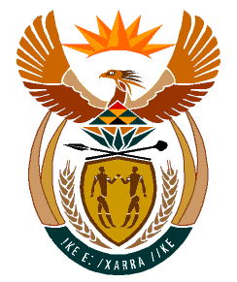

MINISTRY:
HUMAN SETTLEMENTS, WATER AND SANITATION
REPUBLIC OF SOUTH AFRICA

NATIONAL ASSEMBLY

QUESTION FOR WRITTEN REPLY

QUESTION NO.: 1198

DATE OF PUBLICATION: 18 OCTOBER 2019

Mr R A Lees (DA) to ask the Minister of Human Settlements, Water and Sanitation:
(1) With regard to water supply to the town of Utrecht in KwaZulu-Natal, what are the details of the (a) reasons that there was no water available from 30 September 2019 to 8 October 2019, (b) action has been taken against officials who were responsible for the nonavailability of water, (c) action taken to prevent any further disruptions of water supply and (d) demands made by the Utrecht community;
(2) whether all the demands of the community have been agreed to and met; if not, why not; if so, what are the relevant details? NW2408E

REPLY:

(1) The KwaZulu-Natal regional office of the Department of Water and Sanitation (DWS) is aware that there was a water supply interruption from 30 September to 8 October 2019 in the town of Utrecht. The interruptions were as result of a labour dispute between the Amajuba District Municipality and their employees, relating to benefits that were paid and later deducted from employees’ salaries. Following a settlement in the dispute, water supply was restored on 8 October 2019.

(2) It is suggested that the Honourable Member refer the question to the Minister of CoGTA and Traditional Affairs who will be in a better position to respond to additional questions regarding the matter.

