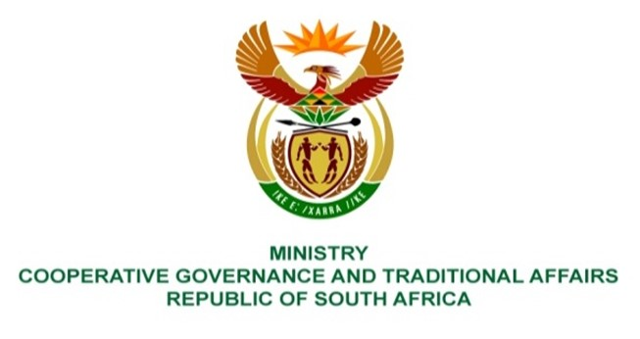

NATIONAL ASSEMBLY
WRITTEN

QUESTION NUMBER 1194
DATE OF PUBLICATION: 25 MARCH 2022

QUESTION:

1194. Mr K Ceza (EFF) to ask the Minister of Cooperative Governance and Traditional Affairs:
Noting how a number of fire managers do not hold legal fire diplomas in accordance with the South African Qualifications Authority Act, Act 58 of 1995, but are made to run the emergency services of the public whereas qualified managers hold junior positions, what (a) action has she taken to hold municipalities accountable for such irregularities and (b) oversight mechanisms has her department implemented to monitor the redress of the situation? NW1456E

REPLY:
It is important to note that the Fire Brigade Services Act, 1987 (Act 99 of 1987) is the primary legislation regulating the provision of fire services. Section 5 (1) a controlling authority shall appoint a person who possesses the prescribed qualifications and experience, as chief fire officer to be in charge of its service. In response to the above questions:
- What action has she taken to hold municipalities accountable for such irregularities?
The Directorate facilitated the process of developing Fire Service career path as part of Municipal Staff Regulations which will come into effect from 1 July 2022.
- What oversight mechanisms has her Department implemented to monitor the redress of the situation?
The Department is in the process of developing an oversight mechanism for Municipal Fire Services career path once the Regulations is effective. The Directorate will monitor and support the implementation of the Municipal Staff Regulations.

The link to the Municipal Staff Regulations is below
https://www.gov.za/sites/default/files/gcis_document/202109/45181gon891.pdf

BACKGROUND INFORMATION:

