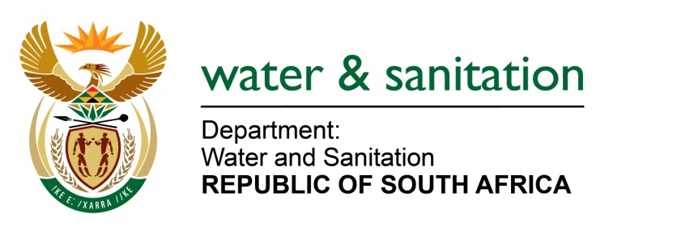

NATIONAL ASSEMBLY

FOR WRITTEN REPLY

QUESTION NO 1193

DATE OF PUBLICATION IN INTERNAL QUESTION PAPER: 22 APRIL 2016
(INTERNAL QUESTION PAPER NO. 12)

1193. Mr L J Basson (DA) to ask the Minister of Water and Sanitation:
With reference to an oversight visit conducted at the Clanwilliam Dam on 23 March 2016,
(a) when will the tender documents be completed by Bigen Africa and
(b) how will the delay in the completion of the specified documents affect (i) the costs and
(ii) the completion date of the project? NW1333E
---00O00---
REPLY:

(a) The draft tender documents have been submitted to my Department for review prior to finalisation and approval.
(b) The scope of works for inclusion in the tender documentation remains the same as originally envisaged.
(b)(i) The cost of the construction for raising of the "dam wall" is based on the scope of works, which will not be affected by the time of preparing the tender documents.
(b)(ii) The anticipated completion date for the project remains set for the 2021/22 financial year.
---00O00---

