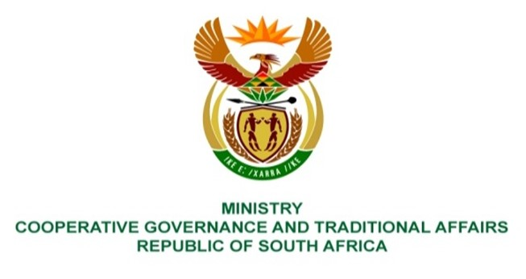

NATIONAL ASSEMBLY
QUESTIONS FOR WRITTEN REPLY

QUESTION NUMBER 1191
DATE OF PUBLICATION: 25 March 2022

QUESTION:

1191. Mrs C C S Motsepe (EFF) to ask the Minister of Cooperative Governance and Traditional Affairs:
Whether she intends to intervene to implement relief measures for the residents of Bela-Bela in Limpopo, who have had to deal with stinking, brown, dirty water for a period of over two weeks without any intervention from the municipality; if not, why not; if so, what are the relevant details of the intervention? NW1453E

REPLY:
Water Service Authorities (WSAs) are required to monitor the quality of drinking water as per the South African National Standard 241 (SANS 241). The SANS 241 is a drinking water specification that provides the minimum requirements for potable water to be considered safe for human consumption. These requirements include microbiological, chemical and physical properties of water.

The Department of Water and Sanitation (DWS) monitors the management of drinking water quality compliance by WSAs and further engages the WSAs where non-compliance is detected. WSAs are required to register for the monitoring programme on the DWS’s Integrated Regulatory Information System (IRIS). The monitoring program indicates the sampling point, frequency of monitoring and what determinants are monitored. All the drinking water quality results must be uploaded on the IRIS as required.

According to DWS, DWS has resuscitated the Blue Drop Certification Programme which aims to address the challenges associated with the provision of water. This programme seeks to implement a proactive drinking water quality risk management approach to ensure that quality failures are minimised, but when and where it inevitably occurs that acceptable responses are implemented to safeguard affected communities.

In the event of non-compliance to provide access to potable water, section 63 of the Water Services Act, No. 108 of 1997 provides, among other things, as follows:

“(1) If a water services authority has not effectively performed any function imposed on it by or under this Act, the Minister (Minister of Water and Sanitation) may, in consultation with the Minister for Provincial Affairs and Constitutional Development (then), request the relevant Province to intervene in terms of section 139 of the Constitution.
(2) If, within a reasonable time after the request, the Province—
(a) has unjustifiably failed to intervene; or
(b) has intervened but has failed to do so effectively, the Minister (Minister of Water and Sanitation) may assume responsibility for that function to the extent necessary—
    - to maintain essential national standards;
    - to meet established minimum standards for providing services…”

In light of the above, it is suggested that this parliamentary question be redirected to the Department of Water and Sanitation (DWS).

