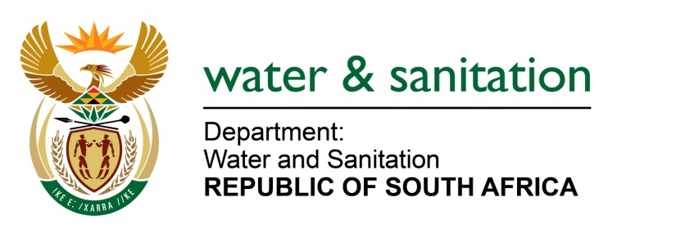

NATIONAL ASSEMBLY

FOR WRITTEN REPLY

QUESTION NO 119

DATE OF PUBLICATION IN INTERNAL QUESTION PAPER: 11 FEBRUARY 2016
(INTERNAL QUESTION PAPER NO. 1)

119. Mr L J Basson (DA) to ask the Minister of Water and Sanitation:
(a) How many of the 1 028 wastewater collector systems which were assessed for compliance with effluent discharge standards in the 2014-15 financial year and (i) did not comply, (ii) what is the location of each of these and (b) what action has been taken to remedy the situation in each case? NW119E
---00O00---
REPLY:

(a) The water supply systems that were assessed in 2014-15 financial year were totaling at 842 waste water collector and treatment systems and the results have been published in the 2014 Green Drop Report. This information is also available on my Departmental website at www.dws.gov.za/Dir_WS/GDS/News/NewsDefault.aspx
---00O00---

