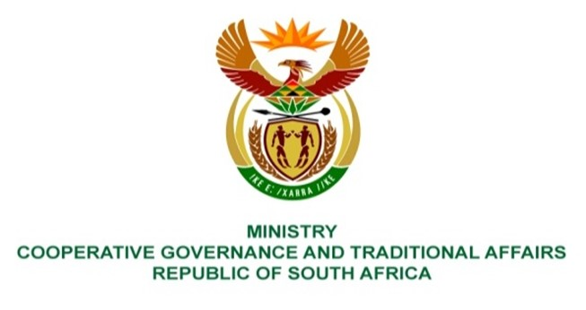

NATIONAL ASSEMBLY
QUESTIONS FOR WRITTEN REPLY

QUESTION NUMBER 2021/1185
DATE OF PUBLICATION: 07 MAY 2021

Ms S A Buthelezi (IFP) to ask the Minister of Cooperative Governance and Traditional Affairs:
QUESTION:

In light of the announcement by the President of the Republic, Mr M C Ramaphosa, of 27 October 2021 as the date for the local government elections, what are the details of the measures that she intends to put in place to balance COVID-19 restrictions with the opening of political spaces for campaigning? NW1375E
REPLY:

We are carefully monitoring developments with regards to the COVID-19 pandemic. Government has gazetted a number of regulations to limit the negative impact of the COVID-19 pandemic. Adjusted levels 1 and 2 of the regulations have opened more space for political activity. While these Regulations are in place, preparations made for the recent by-elections and the upcoming local government elections by stakeholders such as the Independent Electoral Commission (IEC), political parties, government, communities etc, must be done in accordance with the provisions set out in the Regulations.

Working closely with the IEC, we have put processes in place in response to challenges that come with a global pandemic. The IEC has recently appointed Justcie Dikgang Moseneke to lead the inquiry into ensuring free and fair local government elections during Covid-19. The salient features of the terms of enquiry for the inquiry are to:

- Enquire into, make findings and report on, and make recommendations concerning the likelihood that the Electoral Commission would be able to ensure that the forthcoming 2021 general local government elections will be free and fair, in view of –

- challenges posed by the COVID 19 pandemic; and
- measures promulgated by the government to curb the continued spread of the pandemic; and

- Indicate additional measures that the Electoral Commission may be required to implement in order to realise free and fair elections within the context of the COVID-19 pandemic.

The IEC is also considering the introduction of an on-line platform to enable the registration of eligible voters.

The regulations may change going forward, depending on the Covid-19 situation, and advice from the Minister of Health and the National Coronavirus Command Council.

