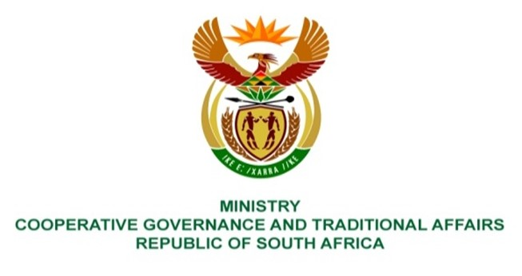

NATIONAL ASSEMBLY
QUESTIONS FOR WRITTEN REPLY

QUESTION NUMBER: PQ 1184
DATE OF PUBLICATION: 7 May 2021

QUESTION:

1184. Ms S A Buthelezi (IFP) ask the Minister of Cooperative Governance and Traditional Affairs:

What has she found to be the ramifications of her publication of a notice in the Government Gazette extending the national state of disaster to 15 May 2021 on preparations for the local government elections? NW1374E

REPLY:

The extension of the national state of disaster to 15 May 2021 by implication also extends the Regulations (GN R 480 as published in Government Gazette 43258 as amended) made in terms of Section 27(2) of the Disaster Managent Act, 2002.

The regulations are designed to limit the negative impact of the COVID-19 pandemic and whilst these regulations are in force, preparations made for the local government elections by stakeholders such as the Independent Electoral Commission, political parties, government, communities etc, must be done in accordance with the provisions set out in the regulations.

