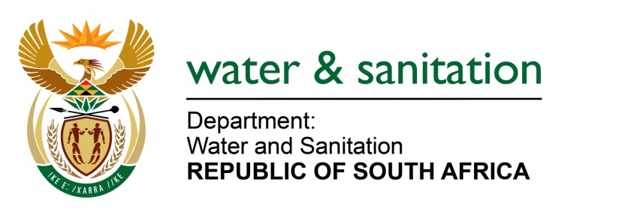

NATIONAL ASSEMBLY

FOR WRITTEN REPLY

QUESTION NO 1183

DATE OF PUBLICATION IN INTERNAL QUESTION PAPER: 22 APRIL 2016
(INTERNAL QUESTION PAPER NO. 12)

1183. Mr H C CKrüger (DA) to ask the Minister of Water and Sanitation:
With reference to her reply to question 390 on 11 March 2016, what percentage of the total procurement of (a) her department and (b) every entity reporting to her went to small-, medium- and micro-sized enterprises (i) in the 2015-16 financial year and (ii) since 1 April 2016? NW1322E
---00O00---
REPLY:
- The Department procured goods and services to the value of R 2,2 billion from the small-, medium- and micro-sized enterprises (SMMEs) in 2015-16 financial year and up to April 2016 as follows:
No. | (b)(i) % SMME’s: 2015/16 Financial Year | (b)(ii) % SMME’s: From 1 April 2016
1. | 50,03% | 1%
(b) The Entities procured goods and services from the small-, medium- and micro-sized enterprises (SMMEs) in 2015-16 financial year and up to April 2016 as follows:
No. | Entity | (b)(i) % SMME’s: 2015/16 Financial Year | (b)(ii) % SMME’s: 1 April 2016
1. | Amatola Water Board | 99.7% | 92.1 %
2. | Bloem Water Board | 37% | 35%
3. | Lepelle Water Board | 72.10% | Not yet available
4. | Magalies Water Board | 22.27% | 22.27%
5. | Mhlathuze Water Board | 66.91% | 72.86%
6. | Overberg Water Board | 13.7% | Not yet available
7. | Rand Water Board | 38% | 3.05%
8. | Sedibeng Water Board | 97% | 35%
9. | Umgeni Water Board | 17.79% | 0.03%
10. | Trans Caledon Tunnel Authority | 1% | 0.20%
11. | Water Research Commission | 21% | 29%
12. | Inkomati CMA | 30% | 23%
13. | Breede-Gouritz CMA | 14.39% | 22.36%
--00O00---

