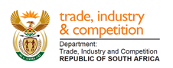

NATIONAL ASSEMBLY

WRITTEN REPLY

PARLIAMENTARY QUESTION 1182

DATE OF PUBLICATION: 11 October 2019

Ms T A Khanyile (DA) to ask the Minister of Trade and Industry:
Whether his department incurred any costs related to the (a) inauguration of the President of the Republic, Mr M C Ramaphosa, held in Pretoria on 25 May 2019 and (b) State of the Nation Address held in Cape Town on 20 June 2019; if so, in each case, (i) what costs were incurred and (ii) for what reason? NW2343E

Reply:
The departments of Trade and Industry and Economic Development advise that they did not incur any additional costs related to the Presidential inauguration as well as the State of the National Address, other than the normal travel costs applicable in the Ministry.

-END-

