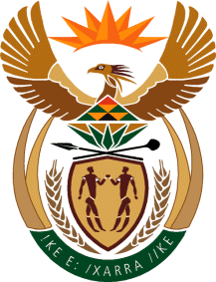

MINISTER OF TOURISM
REPUBLIC OF SOUTH AFRICA

Private Bag X424, Pretoria, 0001, South Africa. Tel. (+27 12) 444 6780, Fax (+27 12) 444 7027
Private Bag X9154, Cape Town, 8000, South Africa. Tel. (+27 21) 469 5800, Fax: (+27 21) 465 3216

NATIONAL ASSEMBLY:

QUESTION FOR WRITTEN REPLY:
Question Number: 1181
Date of Publication: 11 October 2019
NA IQP Number: 18
Date of reply: 28 October 2019

Mr W Horn (DA) to ask the Minister of Tourism:
Whether her department incurred any costs related to the (a) inauguration of the President of the Republic, Mr M C Ramaphosa, held in Pretoria on 25 May 2019 and (b) State of the Nation Address held in Cape Town on 20 June 2019; if so, in each case, (i) what costs were incurred and (ii) for what reason? NW2342E

Reply:
Whether her department incurred any cost related to:
- NO
- and (ii) Not applicable

- NO
- and (ii) Not applicable

